Supplemental Work Sheet for Dam-Affected Communities
All the regions of the world will be impacted by climate change. Solutions to the combined impacts of dams and climate change will need to address the local context, including local geography and weather, political and economic realities, and socio-cultural conflicts and conditions.
The purpose of this supplemental work sheet is to help community members, activists and civil society groups begin to assess and address the climate risks to dams and dammed rivers that are particular to their regions. Facilitators can modify and adapt this work sheet according to your training needs.

How to use
- Create a locally specific version of the work sheet in a new document. Include any case studies from the guide that might be useful. Information on specific river basins may be found here: www.waterandclimatechange.eu. Information on dams can be found here: www.internationalrivers.org
- With the guide as a reference, work through each question through discussion and activities. Field guides for specific community-level assessments can be found here: www.timmagee.net/field-guide-to-cba and http://www.careclimatechange.org/cvca/CARE_CVCAHandbook.pdf.
- Optional: Depending on your group, consider printing out copies of the glossary, Appendix 1: Key Resources, and Appendix 3: Key Questions for Assessing Climate Risks of River Projects for participants.

A. Local community-based assessments
Directions: With just the knowledge you have from your own experience and the experience of those around you, answer the following questions.
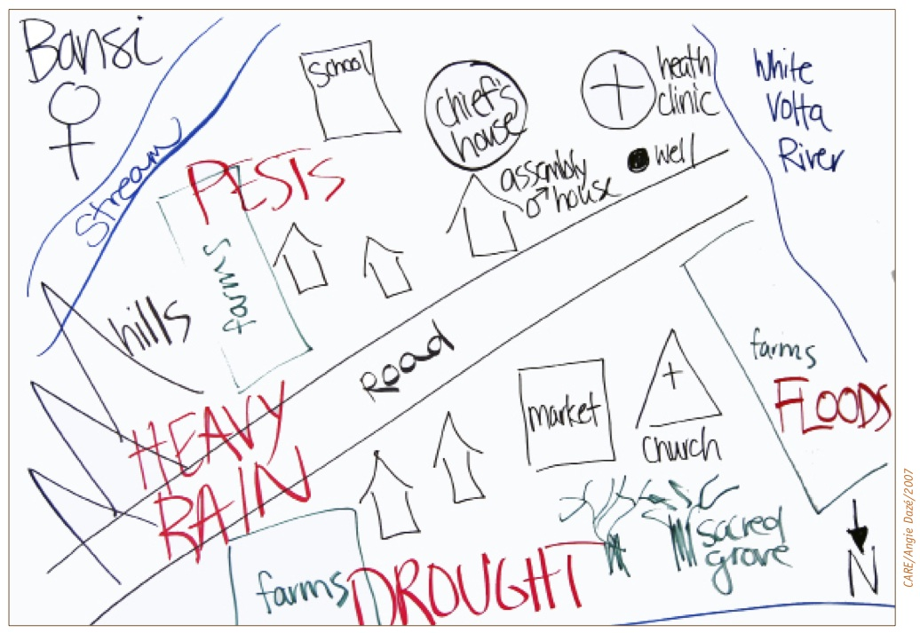
- What local climate impacts and extreme weather events are you seeing in your region? With the group, draw a hazards map of your watershed (this example from CARE).

- What are key community-wide events and activities that typically happen throughout the year? As a group, develop a calendar for the year that includes: holidays and festivals; planting, harvest and fishing seasons; periods of typical resource scarcity, human migrations, rainy and dry seasons, flooding season, fire season, etc. (This activity will help identify periods of stress and changes in seasonal activities.)

- What are major past events such as natural disasters and changes in land use, land tenure, food security, and/or social or political transitions that have occurred in your community’s memory? (This will help to identify more long-term trends.)

- How are weather-related hazards impacting your livelihoods, health and basic needs over time? (This will help assess some of the vulnerabilities of your community.)

Food:

Water:

Income generation:

Health:

Energy use:

Education:

Other areas:

- What are some projects or programs that already exist that are helping your community deal with these problems? (Please state whether these projects or programs are being run by local/national government, NGO or communities themselves)

- Climate risks of dams to communities
Directions: Go through the Key Questions in Appendix 3 and use them to assess the climate risk of the project(s) that are affecting your community or region.
- At what stage(s)* are the projects? Circle the stage.

Project name:
Planning (SEA, water/energy blueprint, etc.) / Project identification / Feasibility studies / Project design / EIA / Site preparation / Under construction / Completed, monitoring & evaluation / Relicensing / Decommissioning or removal / Rehabilitation

Project name:
Planning Stage: (SEA, national water/energy plans, etc.) / Project identification / Feasibility studies / Project design / EIA / Site preparation / Under construction / Completion, monitoring & evaluation / Relicensing / Decommissioning / Rehabilitation

* Suggestions for what to do at different project stages can be found starting on page 24 of International Rivers’ “Dams, Rivers, and Rights - An Action Guide for Communities,” which may be a useful reference for subsequent activities. See: www.internationalrivers.org/node/4156.

- What are some of the risks to community resilience from these projects? If you are unsure, make a note of it and mark it for further research or consultation with a regional expert.

Water resource availability:

Local economy:

Income generation:

Energy access:

Food security:

Health and safety:

Community governance and cohesion:

- What are some of the main climate risks to the projects?

Soil erosion and sedimentation:

River flow:

Economic feasibility:

Reduced electrical output:

Structural integrity and dam safety:

- Referring to the Key Questions in Appendix 3, which questions are most important to you and for which you would want answers?

SOCIAL IMPACTS

ENVIRONMENTAL IMPACTS

ECONOMIC AND SAFETY IMPACTS

- Who in government, industry and/or civil society can you contact regarding these questions?

C. What to do next
Directions: Use the following activities to determine who might be sympathetic and willing to talk to you, and what strategies you might undertake to move your community or region towards greater climate resilience. Civil society groups such as NGOs are sometimes better positioned than government or academic institutions to help communities undertake adaption activities, while also being a bridge among community members, decision-makers and the media.
- Develop a “power map” of all the relevant national and regional level organizations (governmental and nongovernmental) on the graph below. Think about their level of influence regarding the dam project and river management, and whether these actors have a mandate to address climate change.
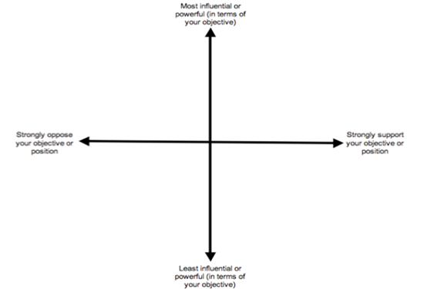
2. Based on this power map, brainstorm some immediate (say, within one month) and long-term (within the next few months) strategies with clear targets you can take to move your communities or regions toward greater climate resilience. Below are some ideas for possible follow-up strategies:
- Conduct in-depth awareness-raising and mapping activities around vulnerability, capacity, and needs with local communities.
- Take photos and use satellite imagery (if available) to document climate- and dam-related disasters, and share these with decision-makers and the media.
- Mobilize communities and resources to plan and develop local adaptation projects that increase community climate resilience, protect ecosystems and sustainably manage resources. Assist government and public adaptation agencies that are already developing and deploying climate smart responses and adaptation solutions.
- Write to decision-makers with unanswered Key Questions regarding river projects that will affect or are affecting the community.
- Lobby the government to improve the decision-making and regulatory framework to increase public participation, transparency, sound science, and the kind of development that meets the needs of the most vulnerable.

A. Short-term strategies:

Barriers:

What do you need to overcome these barriers?

B. Long-term strategies:

Barriers:

What do you need to overcome these barriers?

