Downstream Climate Change Maladaptation Risks of the Gibe III Dam and Kuraz Sugar Plantations

Narissa Allibhai
Master of Development Practice 2014 candidate
University of California, Berkeley

2nd February 2014

Table of Contents

- Executive Summary…………………………………………………………………………………...……...…2
- Introduction……………………………………………………………………………………………...…………2
- Livelihoods Dependent on the Omo River downstream of Gibe III
  - In the Lower Omo Valley……………………………………………………………………………5
  - Around Lake Turkana………………………………………………………………………………..5
- Climate Trends and Indigenous Adaptation
  - In the Lower Omo Valley……………………………………………………………………………6
  - Around Lake Turkana………………………………………………………………………………..8
- Climate Maladaptation Risks of the Gibe III Dam and Kuraz Sugar Plantations
  - In the Lower Omo Valley……………………………………………………………………………9
  - Around Lake Turkana……………………………………………………………………………...12
- Questions for Consideration…………………………………………………………………………….....14
- References……………………………………………………………………………........................................16

1. Executive Summary

The Gibe III hydropower dam currently under construction on Ethiopia’s Omo River is a topic of controversy. What will be the tallest dam in Africa is being built by the Ethiopian government with the aim of generating 6500 GWh of hydropower per year, mostly for export. The project has come under much criticism regarding destruction of ecosystems, displacement of indigenous communities downstream of the dam, loss of resources for the communities’ livelihoods, human rights abuse, risk of resultant conflicts, and insufficient accounting for hydrological risks. The government is also creating large sugarcane plantations downstream in the Lower Valley of the Omo River as part of their Kuraz Sugar Development Plan. This scheme to grow sugar for export and domestic use will be irrigated by flows provided by Gibe III, and will abstract such significant amounts of water from the river that indigenous populations downstream will be unable to continue their established livelihoods dependent on the flow of the Omo River. Inhabitants of the Lower Omo Valley are being forcibly evicted and resettled in new government-created villages. After resettlement they are intended to make up a portion of the work force for the sugar farms and factories. Further downstream, Kenya’s Lake Turkana receives 90% of its inflow from the Omo River. The lake’s ecosystem and livelihoods of dependent populations are at severe risk of destruction if the irrigation projects continue as planned. Climate projections for regions downstream of the Gibe III dam predict increased temperatures, and lower rainfall in the growing seasons. These projections have not been taken into account in project planning and impact assessments, yet have important implications, including increased water demand. Suitability studies of the land allocated to sugar plantations call into question their feasibility and reveal further unaccounted for water demand. With regard to indigenous populations downstream of Gibe III, the dam and sugar projects will increase their vulnerability to climate change, whereas alternative actions could be taken to increase their resilience.

2. Introduction

The Gibe III Dam on Ethiopia’s Omo River is reportedly 80% complete and is expected to being producing some power in September 2014 (GoE 2013). At a height of 243m from basin floor to rim, it will be the highest dam in Africa. Commissioned by the Ethiopian government as part of the Five Year Growth and Transformation Plan (GTP), it is projected to have an average generating capacity of 1,870MW. About 900MW will be exported, of which 500MW will go to Kenya (Araya 2013).

Downstream of Gibe III lie two UNESCO World Heritage sites, the Lower Valley of the Omo River and Kenya’s Lake Turkana. The dam will alter the Omo River’s natural flood regime, impacting downstream ecosystems and communities. The reservoir will hold approximately 14.7 billion m³ of water at maximum capacity, an amount equivalent to a year of the Omo River’s flows (UNEP 2013). Neither the Omo-Gibe River Basin Integrated Development Master Plan nor the Environmental and Social Impact Assessment for the Gibe III Hydroelectric Project addresses effects on Kenya’s Lake Turkana (Woodroofe et al. 1996, EEPCO 2009). Consultation with indigenous community representatives in the Lower Omo Valley was negligible and only occurred after constructed started (International Rivers 2009). Communities in Lake Turkana have not been consulted at all (ibid.).

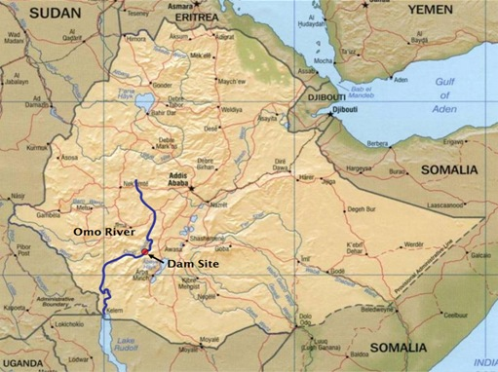
Figure 1. Gibe III Dam site, on the Omo River, in Ethiopia. Downstream, across the Kenyan border is Lake Turkana (labelled as Lake Rudolf, its former name). Source: EEPCO.

Since May 2011, large-scale sugarcane plantations are being developed in the Lower Omo Valley, under the Kuraz Sugar Development Plan (Oakland Institute 2011). The project includes building sugar factories and exporting sugar to the international market (Ethiopia Sugar Corporation 2013). Irrigation of these sugar plantations will require drastic withdrawal of water from the Omo River through Gibe III. Plans for three sugar blocks cover a total area of approximately 245,000 hectares (Oakland Institute 2011), an area almost equal to the entirety of the current irrigated area in Kenya (Avery 2013). Oakland Institute also describes plans for 15 more land concessions of 111,000 hectares to the private sector, mainly for cotton production (Anonymous 2013). The land designated to the sugar estates includes lands separating two national parks and is thus expected to prevent seasonal wildlife migrations (ibid.). Local people displaced by the sugar plantations are being settled into communities as part of the government’s “villagization program” with the idea that they can find jobs on the sugarcane plantations (Ethiopia Sugar Corporation 2013). Though villagization is claimed to be voluntary, the indigenous people have little choice after being evicted from lands intended for plantations.

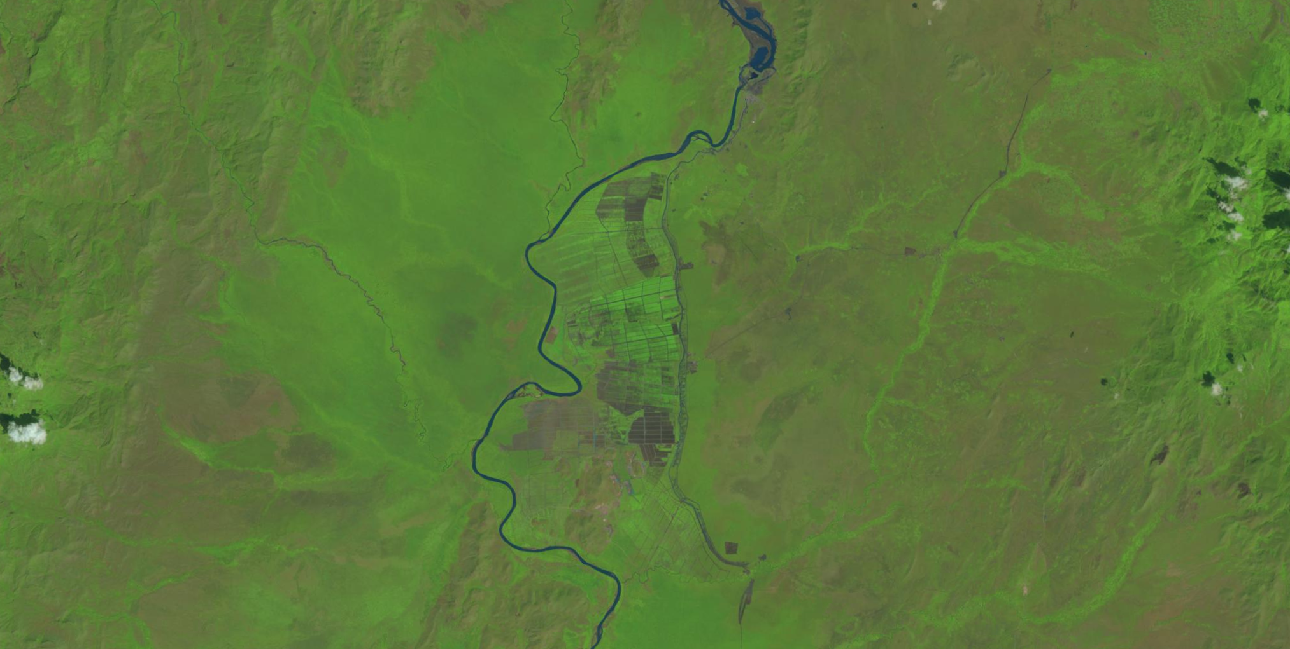
Figure 2. A 29th November 2013 satellite image of the beginnings of sugar block 1. Source: USGS Landsat.

The Omo River feeds into Lake Turkana, a trans-boundary lake mostly in Kenya, and provides 90% of its freshwater and nutrient inflow. The lake is situated in an extremely arid region of the Rift Valley. If the dam and sugar projects proceed as planned, the lake’s ecosystem and livelihoods of dependent populations are at risk of imminent destruction due to severe drops in Omo inflows and artificial regulation of the natural hydrological flood cycle.

An increase in resource conflict is another anticipated consequence of Gibe III and the plantations. Studies describe the escalation of armed conflict between tribes of the Lower Omo and Lake Turkana, as people migrate in search of disappearing food resources (Carr 2012). Conflict is especially rampant in border areas and the Ilemi Triangle, an area in border dispute between Ethiopia, Kenya and South Sudan.

The African Development Bank, the World Bank, and the European Investment Bank withdrew funding consideration for the dam in 2010. The project’s main external funding partner then became the Industrial and Commercial Bank of China, which loaned $500 million to Chinese subcontractor Dongfang Electric Corporation. The Ethiopian Electric Power Corporation (EEPCo), owned by the state, is in charge of the dam project, and awarded the project contract without a bid to the Italian construction company Salini Costruttori.

This paper focuses on downstream climate maladaptation risks of the dam and sugar development projects. Barnett and O’Neill define maladaptation as “action taken ostensibly to avoid or reduce vulnerability to climate change that impacts adversely on, or increases the vulnerability of other systems, sectors or social groups.” None of the official impact assessments so far have taken into account the changing climate that the Gibe III dam and Kuraz Sugar will be subject to. This paper aims to begin to address the effects these projects will have on indigenous people’s ability to adapt to climate change.

3. Livelihoods Dependent on the Omo River Downstream of Gibe III

A. In The Lower Omo Valley

Downstream of Gibe III is the semi-arid Lower Omo Valley, nestled within the Great Rift Valley. The area receives bi-annual rainfall: “Belg” rains from March-June (the secondary growing season) and “Kiremt” rains from June-September (Ethiopia’s main “meher” growing season). The Lower Omo Valley is inhabited by a wide variety of ethnic groups, including the Bodi, Dasanech, Hamer, Karo, Kwegu, Mursi, Nyangatom, and Suri. Occasional small-scale conflicts sometimes occur over scarce resources, including water and pasture (Human Rights Watch 2012); population growth is increasing resource competition. Approximately 200,000 people rely on the Omo River for their livelihoods, which are mainly pastoralist and agro-pastoralist, with some hunting and fishing (Avery 2013). Many practice flood-recession agriculture: in the wet season, farmers move to higher ground in anticipation of the annual flood. The Omo River inevitably floods its banks, replenishing soil nutrients with sediment deposits. Once the waters retreat in September/October, the farmers move back to the riverbanks to cultivate the fertile land, which yields harvests in December/January (Greste 2009, Avery 2013). Similarly, the annual floods renew pasture soils and trigger migratory fish to start spawning (International Rivers 2009).

B. Around Lake Turkana

Further down the Great Rift Valley, 600 km downstream of Gibe III, the Omo River ends its course in the closed basin of Lake Turkana. Human life is believed to have originated here in the “Cradle of Mankind”. Situated in a very arid area of Kenya, the world’s largest “desert lake” is the heart of a fragile ecosystem. 90% of Lake Turkana’s inflow come from the Omo River, bringing with it sediments containing essential nutrients, salts, and minerals (Avery 2013, Avery 2012). The lake boundaries extend into Ethiopia during high flows and withdraw into Kenya during lower flows. Various ethnic groups living around the lake include the Dasanach, El Molo, Gabbra, Rendille, Samburu, and Turkana. The 300,000 people living off Lake Turkana have varied livelihoods—most fish or keep livestock (cattle, sheep, goats, camels, donkeys), some practice flood-recession agriculture, a few hunt for crocodiles and hippos, and a few are camel pastoralists (Avery 2013). All of these livelihoods are made possible by the ebbs and flows of the Omo River. The seasonal floods create breeding areas for fish, enable flood recession agriculture, and reduce the lake’s salinity. Turkana District’s human population has increased significantly while the livestock population has remained stable, resulting in a rising dependence on food aid (Avery 2013).

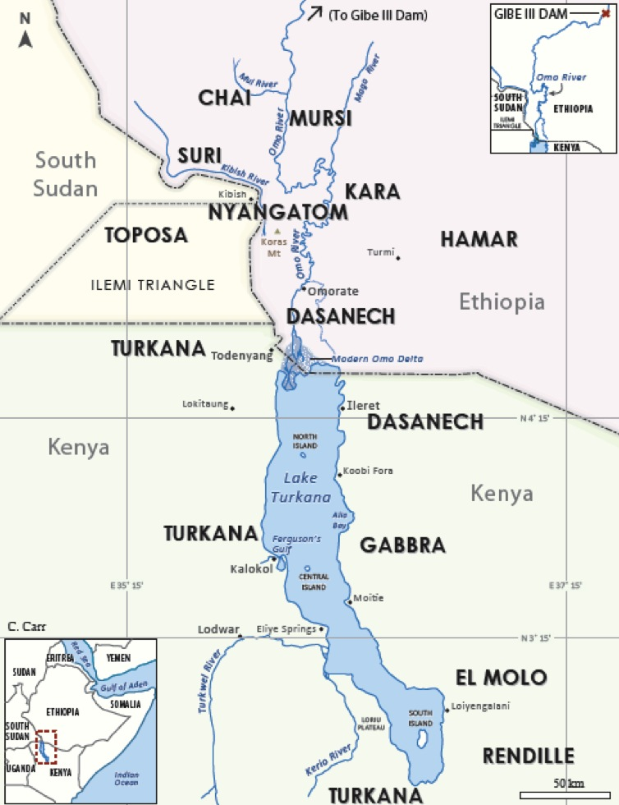
Figure 3. Tribes of the Lower Omo Valley and Lake Turkana. Source: Carr 2012.

4. Climate Trends and Indigenous Adaptation

A. In The Lower Omo Valley

As global temperatures increase due to human activity, the Indian Ocean is warming particularly quickly (Williams and Funk 2011). The rising air above it subsequently loses its moisture through rain sooner, moves west and descends over East Africa, bringing with it extremely dry conditions that particularly affect Ethiopia and Kenya (ibid.). Rainfall in these countries is predicted to continue to decrease, given the trend of increasing global temperatures. An April 2012 Climate Trend Analysis by USAID’s FEWS NET (Famine Early Warning Systems Network) states that Kiremt and Belg (entire growing season) rainfall have fallen by 15-20% across parts of southwest Ethiopia. Reductions in Belg rainfall have been especially significant which increases risks of growing long cycle crops, including sugarcane. Droughts in Ethiopia as a whole have increased by approximately 40% (ibid.). Such reductions in rainfall are associated with lower agricultural harvests and worsened rangeland conditions, increasing people’s vulnerability.

In addition to a continued trend of decreasing rainfall, the FEWS NET report also predicts temperature increases in excess of 1°C in the Lower Omo Valley. Temperatures have already been rising over the last 50 years, and the minimums and maximums have become more extreme (Oxfam International 2010). Higher temperatures mean a greater water demand by humans and plants on the river, which could result in reduced stream flow (International Rivers 2013).

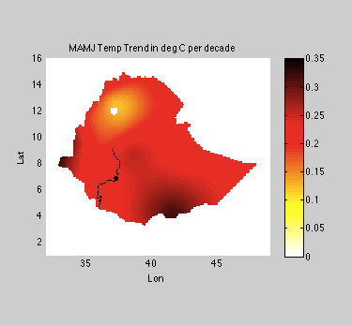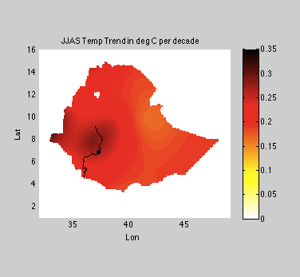
Figure 4. Decadal temperature trends in Ethiopia for the growing seasons Belg (MAMJ) and Kiremt (JJAS). Almost the entire country shows a warming trend, including the entire Omo watershed. Plots by: Narissa Allibhai. Data source: FCLIM_TRENDS/ dataset used for USGS fact sheet on Ethiopia 2012.

Agriculture and pastoralism are climate-sensitive livelihoods, and Ethiopia has a history of much climatic variation, even before considering climate change. The tribes of the Lower Omo have historically adapted to a harsh environment and weather extremes. However, climate change presents new challenges that they may not be prepared to face. Oxfam states: “Small-scale farmers and pastoralists in Ethiopia are likely to bear the brunt of the negative impacts of climate change in the region, which will include increased poverty, water scarcity, and food insecurity” (press release, 2010). All over Ethiopia, farmers are already feeling the effects of climate change: they are unable to predict when rains will start, yields have decreased or failed, and crop diseases have become more vicious. Pastoralists are struggling to find good grazing grounds and sufficient water, thus livestock are becoming less productive. Weaker animals are more susceptible to disease. The Nyangatom tribe in particular have suffered from rising temperatures as their sheep refuse to leave the shade in search of grass (HoA-REC and GIZ 2011). Dry growing seasons in agricultural areas also adversely affect pastoralists and agro-pastoralists due to increased cereal prices and lower terms of trade for livestock then being traded for food (FEWS 2012). Increasing climate unpredictability means that people whose livelihoods depend on ecosystem services spend more resources dealing with climate changes. This reduces their resources spent in other areas, increasing their exposure to other shocks such as sickness. Selling of assets often results, futures are insecure, and the entire cycle loops round to an increase in vulnerability (Oxfam report 2010).

Some coping mechanisms that pastoralists and small-scale farmers in Ethiopia have used are described by Oxfam (2010): Pastoralists commonly divide pasture into separate grazing areas for the wet and dry season. Haymaking has recently spread as an option for animal feed during the dry season. There are more tolerant grass species that can be introduced. For the more affluent, camels and goats are better suited for hot, dry weather than cattle. Pastoralists main weapon of resilience, however, is their mobility as they constantly search for grazing land and water (Eneyew 2012). For farmers, changing to more tolerant crop varieties and changing conservation and management practices are common strategies. Another general coping mechanism is livelihood diversification. People also often bring their children home from school to work in order to cope, which increases vulnerability in the long-term (and thus is a form of maladaptation, and should be discouraged). The above-described coping mechanisms give indications of how pastoralists and farmers can be helped to adapt to climate change.

B. Around Lake Turkana

Lake Turkana is in one of the hottest, most arid areas in Kenya. In fact, Turkana county (west side of Lake Turkana) is undergoing long-term drought and famine (Ndanyi 2014). Data from the nearest meteorological station to the lake (Lodwar) approximately 50 km away has shown that maximum and minimum air temperatures have increased by 2-3 °C over the last 45 years (Avery 2012). Not only are air temperatures on the rise in East Africa, but lake temperatures are too (ibid.). Average rainfall in the region is only 150-300 mm (Avery 2013). Rainfall projections vary in different studies, which mostly project slight increases in precipitation. However, this has little consequence on the volume of lake water as rainfall is already so little to start with (Avery 2012). Potential evaporation from Lake Turkana is 10 times the annual rainfall (ibid.). High evapotranspiration rates are amplified by strong winds (Avery 2013).

About 10,000 years ago, Lake Turkana’s surface area was 5 times larger and its water level was almost 100 m higher than today (Avery 2012). Currently shrinking, although above its lowest historical level, the lake is consequently becoming more saline, in turn increasing the region’s vulnerability to climate change (International Rivers 2009, Avery 2012). Any further drain on incoming water could have irreversible effects on the lake’s ecosystem and the people that depend on it. Water is a scarce resource in the Turkana region, and associated challenges are compounded by the trans-boundary aspect of the lake (UNEP 2013).

In response to increasing temperatures, decreasing rainfall, and falling lake levels, people’s livelihoods historically trended away from fishing and farming, and toward pastoralism (Avery 2012). Pastoralism has been a very successful coping mechanism to climate change around Lake Turkana for the last 6000 years (ibid.). Modern-day pastoralism faces many challenges, including population growth, resource competition, land grabs, and increased border conflict (Avery 2013). In recent times, the Kenyan government has encouraged livelihood diversification to include again irrigated agriculture and fishing (Avery 2013). Fishing is a “last resort” activity that many Dasanech have been forced into—in the Dasanech language, the words for “poor man” and “fisherman” are the same (Carr 2012).

Lake Turkana is 90% dependent on Omo inflows for replenishment, so climate changes in Ethiopia affecting the flows of the Omo River has a direct impact on Lake Turkana’s hydrology and ecosystems (see section 4.A.).

5. Climate Maladaptation Risks of the Gibe III Dam and
Kuraz Sugar Plantations

A. In the Lower Omo Valley

On a local level, dams often worsen negative impacts of climate change on downstream river ecosystems and dependent communities by reducing their adaptation capacity (International Rivers 2013). Dams increase the risk of droughts (decrease water security), and of dangerous floods downstream if they are not designed to cope with extreme floods (ibid.). Also, reservoirs are breeding grounds for disease vectors such as malarial mosquitoes, increasing health risks of nearby communities (ibid.). Finally, the blocking of nutrient-rich sediments reduces downstream soil fertility (ibid.).

The Omo River’s floods support flood-recession agriculture, grazing grounds, and the life cycle of migratory fish—it is a lifeline for many communities. In order to mitigate the devastating effects of a loss of the annual floods, the dam planners have discussed releasing a 10-day artificial flood from the reservoir. This short flood will be an insufficient substitute for the natural flood that builds up over several months, and will not be able to sustain established ecology, livelihoods, and economy (International Rivers 2011). Further, the sediment transport capacity of the river will reduce due to fewer flood peaks, which are when most sediment is transported (Avery 2010). Reduced floods will also reduce nutrient replenishment of wetlands downstream (ibid.).

Salini Costruttori said in a press release that they would only release controlled floods for “a transitory period of a suitable duration when it is deemed opportune to switch from flood-retreat agriculture to more modern forms of agriculture” (Salini Costruttori 2010). This shows that the proposed artificial floods are only planned to be temporary. Experts have cast doubt on the likelihood of controlled floods being released at all, as this would harm the sugar farms (Anonymous 2013). Such a scenario is imaginable, given similar unfulfilled promises that occurred with the earlier Gibe I dam. Further, many sugar plantations are planned to be built on land in use by indigenous populations (Human Rights Watch 2012), which gives those populations no choice but to uproot and join the villagization program.

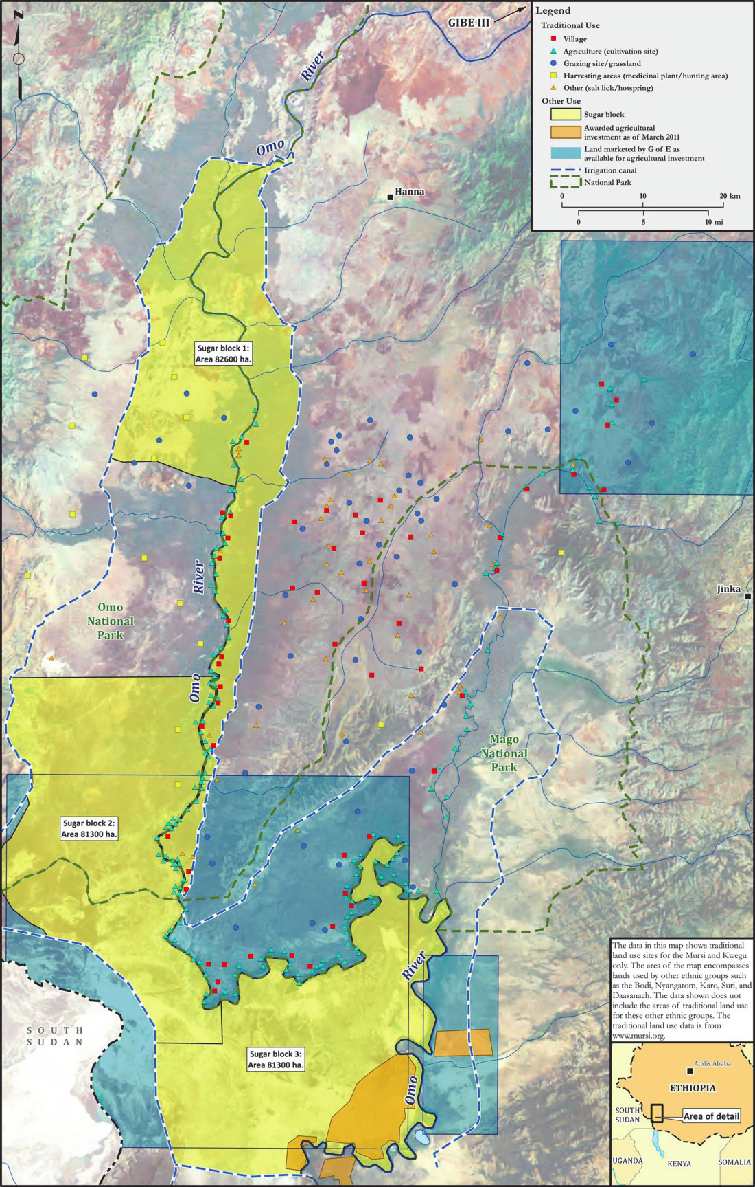
Figure 5. Planned sugar blocks overlap with indigenous land use sites. Source: Human Rights Watch 2012.

Areas receiving sufficient rainfall for sustained rainfed agricultural production have shrunk over the years (Funk et al. 2012). Sugarcane is a long cycle crop and thus is directly affected by reductions in accumulated rainfall over the entire growing season from March-September. Sugarcane’s water requirements are 1500-2000mm (ETm) evenly distributed over the growing season (FAO 2013). A trend of decreasing rainfall, and in particular failing Belg rains, makes it highly unlikely that these requirements will be met. This means that there will be a substantial water demand for irrigation from the Omo River, collected by the Gibe III dam.

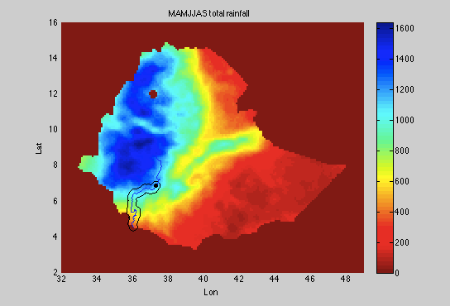
Figure 6. Total projected rainfall in 2025 for the entire growing season, estimated by adding projected rainfall totals for the 2 growing seasons Belg (MAMJ) and Kiremt (JJAS). Examining a 25 km buffer around the Omo River downstream of the Gibe III dam (includes all land allocated to sugarcane farms) reveals that rainfall in these areas is insufficient to grow sugarcane (all below 1500 mm). This map actually overestimates rainfall, as rainfall in the month of June is double-counted, but the conclusion still holds. This means that there will be an excessive water demand for irrigation from the Omo River. Plots by: Narissa Allibhai. Data source: FCLIM_TRENDS/ dataset used for USGS fact sheet on Ethiopia 2012.

Of the 245,000 hectares allocated to the Ethiopian Sugar Corporation for sugarcane, hydrology expert Sean Avery estimates only 161,285 hectares are actually suitable for irrigated sugarcane (2013). Water resources will be further strained because more water evaporates from large reservoirs than rivers (International Rivers 2013). Even more water loss will occur through evaporation and seepage from the unlined canals (Anonymous 2013), evapotranspiration, and water use in the sugar factories. Increased evapotranspiration will also increase soil salinity, which is a risk that depends on the efficiency of the irrigation scheme (Avery 2013).

Rainfall declines are already likely affecting crop yields and pasture conditions in south-central Ethiopia (Funk et al. 2012). Changing the wandering lifestyles of pastoralists toward limited grazing grounds and intensifying water intensive agriculture in such areas will likely increase vulnerability to and effects of the declining rainfall on these people. The 2012 FEWS NET Climate Trend Analysis conjectures an increase of at-risk people, what with growing populations and expansion of farming and pastoralism under warmer and drier climates. They recommend agricultural development in those areas of Ethiopia predicted to retain wet conditions rather than in marginal areas—which would likely rule out the Lower Omo Valley.

Pastoralism in itself deserves more credit as a feasible and sustainable means of livelihood, which is not necessarily inferior to farming in the context of climate change. Ian Scoones, an agricultural ecologist at the Institute of Development Studies, explains that “pastoralists are probably the best of all people on the planet to respond to climate change” (Murray 2012). His research on agriculture in eastern and southern Africa has shown that pastoralists deal better than farmers with extreme weather and climate shocks. The key to their success is in their constant movement—so when resources get diminished in their current location, they move to more suitable areas. In that time, the depleted land replenishes itself. Scoones recommends that governments complement crop farming with “more drought resilient livelihoods” like pastoralism (Murray 2012). He further points out that land grabs of prior pastoral grazing lands for large-scale agricultural projects force pastoralists into smaller areas, which gives land less time to replenish between visits, thus resulting in land degradation.

B. Around Lake Turkana

Gibe III’s reservoir will take at least 1-2 years to fill. During this time, Lake Turkana will lose at least 50% of its inflows from the Omo (International Rivers 2009)—which amounts to at least 45% of its total inflows. During filling, a 25 m³/s minimum flow release is planned (Avery 2013), whereas the average flow has been 438 m³/s, and 61 m³/s in the driest month (International Rivers 2009). Even once the reservoir is filled, the dam will continue to lower the lake’s level as water will be lost through evaporation from the reservoir and from cracks in underground geological rock formations. If extra water is not abstracted for irrigation, research (superimposing dam filling plans on lake levels from 1993-2012) estimates an initial lake level drop to 2 m below the natural lake level, followed by approximately 16 years to restore previous levels (Avery 2013). However, irrigation projects that are currently planned would reduce lake levels a lot more drastically (see next page).

A UNEP 2013 report refers to studies showing that if Gibe III is solely used for hydropower, its impacts on Lake Turkana’s water levels will be within the lake’s natural variability observed since 1992. This statement, however, is nullified if irrigation projects go on as planned. Further, planned future dams Gibe IV and Gibe V will regulate the entire Omo inflow to the lake, eliminating almost all natural variability (Avery 2013). The UNEP study found that if Gibe III was only used for hydropower generation, specific ‘hot spot’ areas of the lake shoreline could recede by up to 2 km in a below-normal future rainfall scenario (UNEP 2013). Given that rainfall projections demonstrate decreases in most areas around the Omo River (Funk et al. 2012), drastic shrinking shorelines are a concern. Regardless of the water levels and shorelines, the lake’s hydrological cycle will be permanently altered according to regulated flows, which will directly lead to destruction of the floodplain ecology and fisheries (Avery 2013).

Leaving aside impacts on Lake Turkana from use of Gibe III for hydropower generation, the most significant and worrying consequences will arise from using the river to irrigate plantations. Up to 50% of Omo inflows to Lake Turkana could be regularly abstracted for irrigation alone, in which case lake levels will drop by over 20m, which is two-thirds of the average depth (Avery 2013). Drastic reductions in biomass and fisheries will ensue, and the lake could even recede so far that it splits into two lakes (ibid.). Reductions in the lake’s volume will also increase its salinity, amplifying health risks for those who drink its water. The development of large irrigated agriculture schemes in the Lower Omo Valley also has the inbuilt risk of fertilizer run-off that could pollute Lake Turkana. This could also trigger algal blooms, which are detrimental to fish and eventually deplete water oxygen levels (Avery 2013).

Lake Turkana currently loses to evaporation a volume of water equal to inflows from the Omo (Avery 2013). Its other source of water is rainfall, at about a tenth of this volume. A rise in temperature will increase evapotranspiration rates, crop water requirements, and thus water volume abstracted from the Omo River (Avery 2013). This, in addition to increased evaporation from the Omo River, Gibe III reservoir, and Lake Turkana, could all reduce levels of water in the lake. The sugar estates will be irrigated by a 200km unlined canal system (Anonymous 2013), which will lead to further water loss to evaporation and seepage. Any rainfall that may increase over the lake will be in amounts negligible to the evaporation effect (Avery 2013).

Sean Avery estimated lake level reductions for different levels of water abstraction from the Omo River (2013). The Omo-Gibe River Basin Integrated Development Master Plan, which did not account for the significant irrigation demand, projected a water demand consisting of 32% of Omo inflow for the year 2024. Even this underestimation, according to Avery’s calculations, will reduce Lake Turkana to levels lower than it has ever experienced, a situation it will never recover from. More realistic estimates yield horrific results: a water demand of 64% would drain the lake to 45m below its lowest levels (note the lake’s current average depth is 31m).

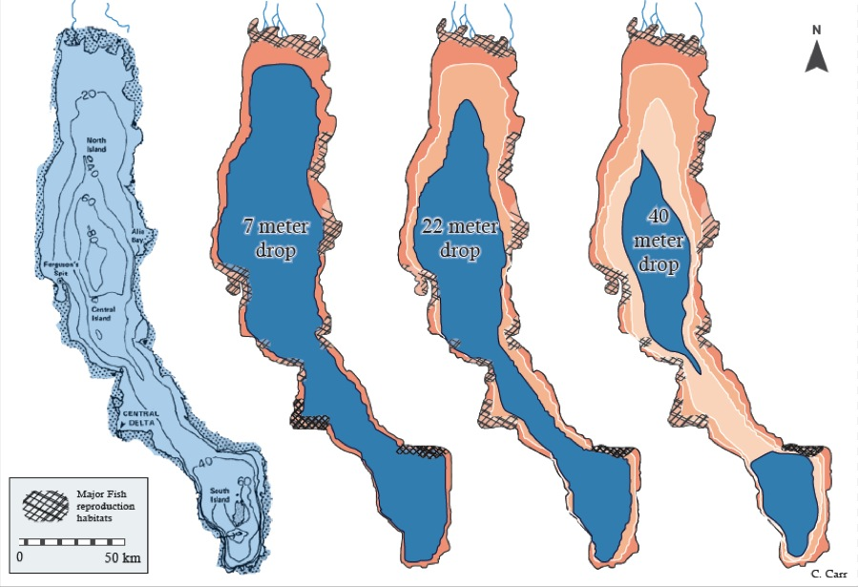
Figure 4. Projected lake recession possibilities. Source: Carr 2012.

6. Questions for Consideration

Energy and Development
  - Could Environmental and Social Impact Assessments (ESIA) of the Gibe III dam be expanded to include:
    - The effects on people dependent on Lake Turkana in Kenya
    - In-depth details of water removal for the Kuraz Sugar Development Plan?
  - Should villagization and clearing of land for the Kuraz sugar farms be put on hold until an updated ESIA is completed? This will allow for fully informed assessment of costs, benefits, and risks, and an overall analysis of the feasibility of the project. Can this feasibility analysis discussion be held in consultation with indigenous communities, and their voluntary consent gained before making any further developments?
  - 95% of Ethiopia’s electrical energy comes from hydropower (Berlin 2010). Over-reliance on hydropower can be risky for a country’s energy security and economy, given future precipitation unpredictability and increases in extreme weather events (Harrison and Whittington 2002). As an example, the 2003 drought led to months of severe power cuts in Ethiopia, which cost the economy an estimated $200 million (International Rivers 2009). Could diversifying Ethiopia’s sources of energy be a route out of dependence on unpredictable rainfall to produce electricity?

Indigenous Livelihoods and Ecology
  - What steps would build on and assist indigenous adaptation to climate change, in ways that are context-specific (to the geography, the changing climate, traditional livelihoods, etc.) and amenable to communities? How can communities be involved in co-creation of adaptation projects?
    - Oxfam recommends recognition of pastoralism as a viable way of life, as well as development of land use policy that works with traditional land use systems (2010). They urge the government to “support pastoralists, especially women, through more efficient service delivery such as improved livestock, market linkages, and livestock health services. Improve access to feed and water for both livestock production and household consumption. Invest in better disaster and conflict management practices to address recurrent drought and conflict.”
    - How can land policy ensure that pastoralists have sufficient land area to move around, giving left-behind land enough time to recover before they return? Official designation of land to pastoralists is one means of achieving this.
    - For farmers, Oxfam suggests the government provide seasonal precipitation forecasts; access to basic agricultural technologies such as plows, new crop varieties, and fertilizers; access to information; improved market linkages; and credit and insurance schemes.
    - What methods of storage can ensure water availability all year round?
    - What food security systems need to be put in place in light of a changing climate?
    - Oxfam encourages diversification of rural livelihoods to non-agricultural sectors to reduce pressure on the land. This calls into question the viability of increasing the scale of agriculture in the semi-arid Lower Omo Valley.
    - How can sharing of best practices be facilitated?
    - What steps are necessary to fully understand traditional coping mechanisms in order to build on them?
  - What steps are necessary to ensure release of sufficient flows and imitation of the natural hydrological cycle to sustain the ecosystems of the Lower Omo Valley and Lake Turkana? Who should take part in this process to ensure its sustainability and adoption?
  - What needs to be done to ensure livelihood security of indigenous populations in Ethiopia and Kenya in the years that the dam reservoir is filling up? Who is responsible for ensuring this, and are they empowered to make necessary changes to river-basin management practices to succeed?
  - Are there other ways to provide pastoralists increased access to health facilities and other basic services without forcing them into villages?
  - Could agro-forestry play a role in adaptation?
  - Oxfam recommends programs in new forestation, reforestation, and sustainable forest management. What would such a program entail? What large-scale agricultural projects need to be reconsidered in the vein of land conservation?
  - What methods of risk management and social protection can the government assist with in conjunction with communities in the Lower Omo?

7. References

Anonymous. "The Downstream Impacts of Ethiopia's Gibe III Dam: East Africa's "Aral Sea" in the Making?" International Rivers. January 2013.
Araya, Elleni. “Ethiopia: Transmission Lines for Gilgel Gibe III to Be Ready Within a Month.” allAfrica. 3 Mar 2013. http://allafrica.com/stories/201303050057.html?page=2 (accessed Dec 11, 2013).
Avery, Sean T. "What Future for Lake Turkana?" Irrigation Development, African Studies Centre, University of Oxford. December 2013.
—. “Lake Turkana and the Lower Omo: Hydrological Impacts of Gibe III & Lower Omo.” Irrigation Development, African Studies Centre, University of Oxford Vols. I and II. October 2012.
—. “Hydrological Impacts of Ethiopia’s Omo Basin on Kenya’s Lake Turkana Water Level and Fisheries.” African Development Bank. November 2010.
Barnett, Jon, and Saffron O’Neill. "Maladaptation." Global Environmental Change 20, no. 2: 211-213. 2010.
Berlin, Marthe. “A Breath of Fresh Air for Ethiopia’s Energy Sector.” GTZ Ethiopia News. 2010.
Carr, Claudia. Humanitarian Catastrophe and Regional Armed Conflict Brewing in the Transborder Region of Ethiopia, Kenya and South Sudan: The Proposed Gibe III Dam in Ethiopia. Africa Resources Working Group, 2012.
EEPCO. “Gibe III Hydroelectric Project Environmental and Social Impact Assessment.” January 2009. http://www.gibe3.com.et/ESIA%20Compresed/300ENVRCS002C_Gibe%20III_ESIA_Jan09.pdf (accessed Dec 10, 2013).
Eneyew, Bantwale Diress. “Climate Change Impact and Adaptation in South Omo Zone Ethiopia.” Wageningen University. August 2012.
Ethiopia Sugar Corporation. Kuraz Sugar Development Project. 8 July 2013. http://www.etsugar.gov.et/en/projects/kuraz-sugar-development-project.html and slideshare http://www.slideshare.net/meresaf/the-omokuraz-sugar-development-project (accessed Dec 8, 2013).
FAO. “Crop Water Information: Sugarcane.” FAO Water. 2013. http://www.fao.org/nr/water/cropinfo_sugarcane.html (accessed Dec 12, 2013).
Funk, Chris, Jim Rowland, Gary Eilerts, Emebet Kebebe, Nigist Biru, Libby White, and Gideon Galu. "A climate trend analysis of Ethiopia." US Geological Survey, Fact Sheet 3053. April 2012.
—. “FCLIM_TRENDS/” dataset. US Geological Survey, Fact Sheet 3053 (2012).
Funk, Chris, Joel Michaelsen, and Michael Marshall. “Mapping recent decadal climate variations in precipitation and temperature across Eastern Africa and the Sahel .” Remote Sensing of Drought: Innovative Monitoring Approaches Ch 14. 2011.
Funk, Chris, Michael D. Dettinger, Joel C. Michaelsen, James P. Verdin, Molly E. Brown, Mathew Barlow, and Andrew Hoell. "Warming of the Indian Ocean threatens eastern and southern African food security but could be mitigated by agricultural development." Proceedings of the National Academy of Sciences 105, no. 32 (2008): 11081-11086.
Government of Ethiopia. “Ethiopia: Gilgel Gibe III Near Completion - to Go Operational in September.” allAfrica. http://allafrica.com/stories/201312171646.html (accessed Feb 2 2014).
Greste, Peter. “The dam that divides Ethiopians.” BBC News. 26 March 2009. http://news.bbc.co.uk/2/hi/africa/7959814.stm (accessed Nov 21, 2013).
Harrison, Gareth, and Bert Whittington. "Climate change-a drying up of hydropower investment?." POWER ECONOMICS 6 (2002): 23-27.
Human Rights Watch. ""What Will Happen if Hunger Comes?"Abuses against the Indigenous Peoples of Ethiopia's Lower Omo Valley." Human Rights Watch. 2012.
International Rivers. “Chapter 2: Understanding the Climate Risks to Rivers and Communities.” In Civil Society Guide to Healthy Rivers and Climate Resilience. 2013.
—. “Ethiopia's Gibe III Dam: Sowing Hunger and Conflict.” Jan 2011.
—. “Fact Sheet: Gibe III Dam, Ethiopia.” May 2009.
Murray, Katie. “Protecting pastoralism a key means of climate adaptation.” Thomson Reuters Foundation. 18 July 2012. http://www.trust.org/item/?map=protecting-pastoralism-a-key-means-of-climate-adaptation-expert/ (accessed Nov 28, 2013).
Ndanyi, Mathews. “Kenya: 400,000 Starving in Turkana.” allAfrica. 17 Jan 2014. http://allafrica.com/stories/201401170576.html (accessed 2 Feb 2014).
Oakland Institute. “Land Deal Brief.” September 2011. http://media.oaklandinstitute.org/sites/oaklandinstitute.org/files/Land_Deal_Brief_Ethiopia_Omo_Valley.pdf (accessed Dec 3, 2013).
Oxfam International. “The Rain Doesn't Come on Time Anymore: Poverty, Vulnerability, and Climate Variability in Ethiopia.” 22 April 2010. http://www.oxfam.org/sites/www.oxfam.org/files/rain-poverty-vulnerability-climate-ethiopia-2010-04-22.pdf (accessed Dec 7, 2013).
—. “Climate change increasing poverty and vulnerability in Ethiopia.” Oxfam press release. 22 April 2010. http://www.oxfam.org/en/pressroom/pressrelease/2010-04-22/climate-change-increasing-poverty-and-vulnerability-ethiopia (accessed Dec 13, 2013)
Salini Costruttori. “Gibe III: The Survival Figures are Obviously Incorrect.” Salini Costruttori Press Release. 30 March 2010.
Survival International News. “Hunger – Ethiopia’s new weapon to force tribes off their land.” Survival International. July 2012.
Tröger Sabine, et al. “Failing Seasons, Ailing Societies – Climate Change and the Meaning of Adaptation in Ethiopia.” HoA-REC and GIZ. 2011.
UNEP. “Balancing economic development and protecting the cradle of mankind - Lake Turkana basin.” UNEP Global Environmental Alert Service. 2013.
USGS. LandsatLook Viewer. 29 Nov 2013. http://landsatlook.usgs.gov/ (accessed Dec 10, 2013).
Williams, A. Park, and Chris Funk. "A westward extension of the warm pool leads to a westward extension of the Walker circulation, drying eastern Africa." Climate Dynamics 37, no. 11-12: 2417-2435. 2011.
Woodroofe, Richard, & Associates. Omo-Gibe River Basin Integrated Development Master Plan Study, Final Report for the Ministry of Water Resources of the Federal Democratic Republic of Ethiopia. Dec 1996.

